Title in Times New Roman (12pt Bold) Using First Capital Letters (Recommended Size: Up to Two Lines)
F. Author¹, S. Author², T. Author^{1,2}
first_author_email@address
(1) Institution, Address, Town, Country
(2) Institution, Address, Town, Country
Abstracts may be rejected unless the following guidelines are respected. The full abstract as presented in this template cannot be longer than 2 pages. Do not use non-standard abbreviations in the title. Abstracts MUST be submitted electronically through the Easychair platform. We recommend typing the abstract over this template in order to ensure the proper formatting: one column of text written in Times New Roman 11pt (justified) with page margins of 1'' (top – bottom) and 1.25'' (left – right). You are encouraged to include Figures and Tables in your abstract. Leave one line (11pt) before and after each Figure. The corresponding captions (Times New Roman 11pt) should follow straight after the Figures, without any line between the Figure and its caption. The abstract should include the following sections:
MOTIVATION/BACKGROUND: Provide some context to orient those readers who are less familiar with your topic and to establish the importance of your work. State the need for your work, as an opposition between what the scientific community currently has and what is needed.
OBJECTIVE: Specify the research question and the data used.
METHODS: Are the steps you took to answer your research questions or a specific list of tasks needed to accomplish the goals of the project. Specify your evaluation measures and methods.
RESULTS: What did you find? What data or outcomes did you observe? What do you compare to?
CONCLUSION: What did your results tell you? Did you find out what you wanted? Why or why not? What should be studied next?

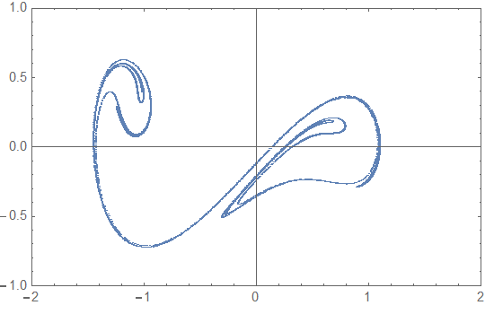
Figure 1: Poincare set of the Duffing equation, for a=0.1, b=0.3

The sections for acknowledgements and references should appear at the end of the abstract (Times New Roman 11pt).
Acknowledgements (optional)
The acknowledgements should be written here. Thank you for spending your time in reading the instructions. Feel free to contact us for any further information.
References (optional)
[1] X. Author, Y. Author, Z. Author, Scientific Reports, 20 (2011) 537.
[2] X. Author, Y. Author, Z. Author, Proc. of Solar Chemistry and Photocatalysis: Environmental Applications, Las Palmas de Gran Canaria, Spain, 2006, 10.

